Important Places of the Texas Revolution
Name_____________________________
Locate and research five important events from the Texas Revolution. Label the map for each event, identify (title) and write a short description in the appropriate box and include a picture related to the event.
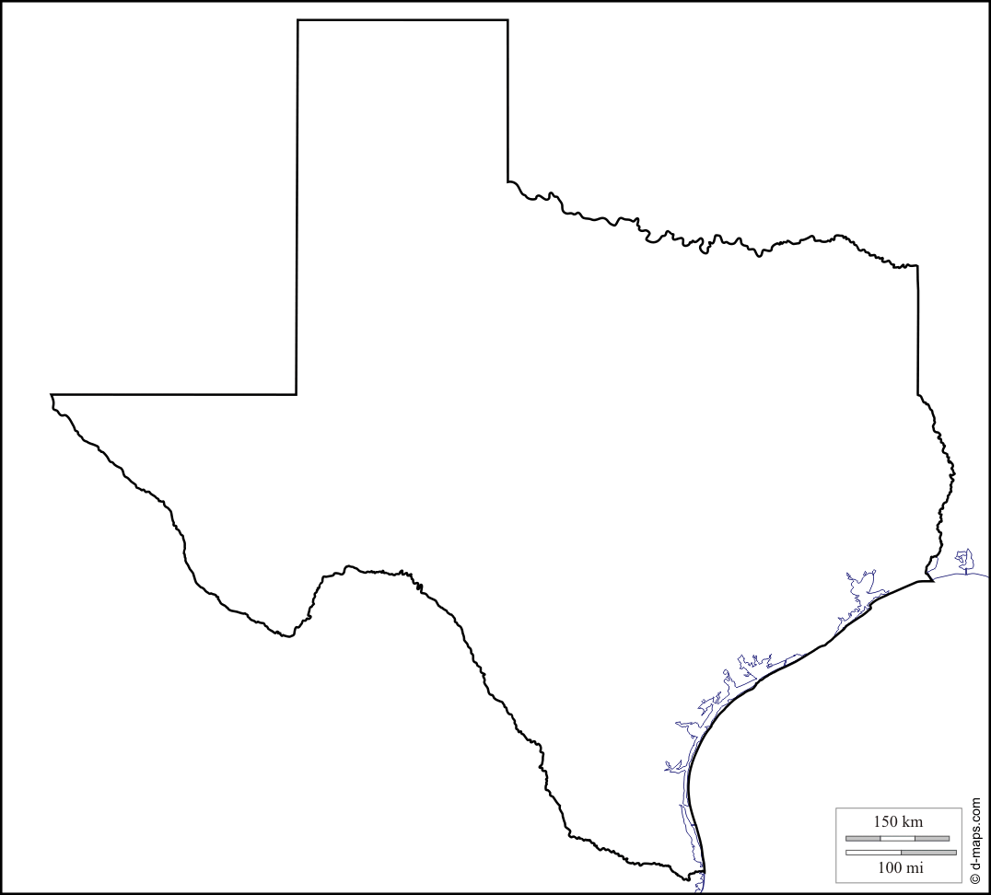

Title/Description | Picture

